PROGRAM 1:-
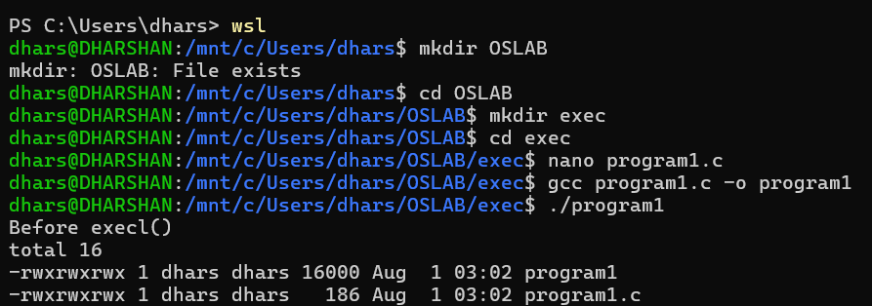
PROGRAM 2:-
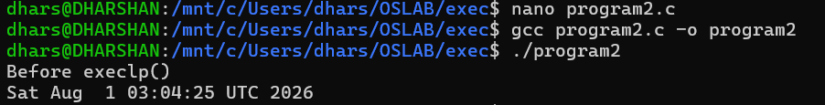
PROGRAM 3:-
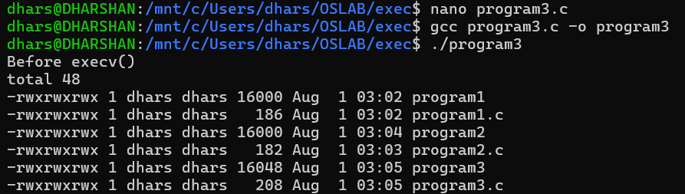
PROGRAM 4:-
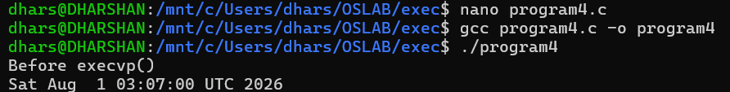

PROGRAM 5:-
